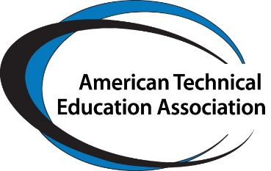

61st Annual National Conference
“Collaboration for Maximum Impact with Applied Learning Focus”
April 10, 11 and 12
Hosted by
President Sheree Utash
WSU Tech, Wichita, Kansas
Details available on ATEA registration page
Trade Show and Sponsorship Registration

The American Technical Education Association (ATEA) and host Dr. Sheree Utash are pleased to announce the 61st Annual National Conference. We would be honored for you to be a sponsor of this conference. As a sponsor at the 2024 National Conference, you will have access to over 200 key decision makers and significant visibility in promotional information through emails to our 2500 network. Participants at the conference will be looking for viable and affordable equipment, software, training units, and other resources. Attendees are respected education authorities who initiate projects and programs. There are several sponsorship opportunities available.

SPONSORSHIP TYPES

4 Conference Platinum Sponsor $10,000
Sector Platinum Sponsor
Platinum is the preeminent conference sponsorship or sector sponsorship.
- Acknowledgement on the ATEA website as a Platinum sponsor, including your company logo and on all conference materials including photo of company leader or leaders.
- 2 Trade Show booths
- 5 complimentary registrations
- Full page ad on digital program
- Sponsor profile in the conference program with website link in digital format
- Acknowledgment in all conference marketing materials
- Opportunity to personally greet attendees at the Trade Show Opening
- Recognition via prominent place in all conference materials at the conference

6 Gold Sponsor $5,000
Gold is the premier conference or sector sponsorship.
- Acknowledgement on the ATEA website as a Gold sponsor, including your company logo
- 2 Trade Show booth
- 3 complimentary registrations
- Sponsor profile in the conference program with website link.
- Acknowledgement in all conference marketing materials
- Recognition at the beginning of each conference day or in the sector session—if a session sponsor

15 Silver Sponsor $3,000
- Acknowledgement on the ATEA website as a Silver sponsor, including your company logo
- 2 complimentary registrations
- 1 trade show booth
- Sponsor profile in the conference program
- Acknowledgement in all conference marketing materials
- Logo visible at the conference general session.

20 Bronze sector sponsor $2,000
- Acknowledgement on the ATEA website as a Bronze Sector sponsor, including your company logo
- Acknowledgement in all conference marketing materials with website link.
- 1 complimentary conference registration
- 1 trade show booth

SPECIAL SPONSORSHIPS

ATEA Awards Program—company name in title of the Awards Program $5,000

Register online at www: ateaonline.org or through this form. We will contact you for full information.
Name__________________________Organization________________________

Level of Sponsorship__________________ Payment method_______________

Please attach logo for all levels and for Platinum or Gold photo of CEO or Person to be featured. Questions, please contact Sandra Krebsbach, ATEA Executive Director skrebsbach@dunwoody.ed or 612-381-3315.

