Hotel Information for 2024 ATEA Conference:

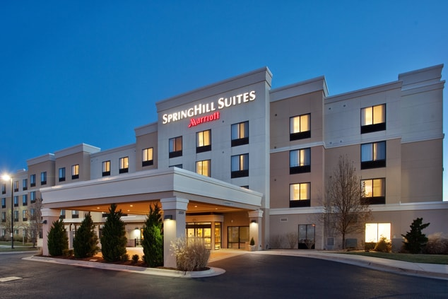
SpringHill Suites Wichita East at Plazzio
1220 North Greenwich Road Wichita, Kansas 67206
$119 USD/Night

https://www.marriott.com/event-reservations/reservation-link.mi?id=1700499282218&key=GRP&app=resvlink

Short Link: https://tinyurl.com/ATEASpringHill

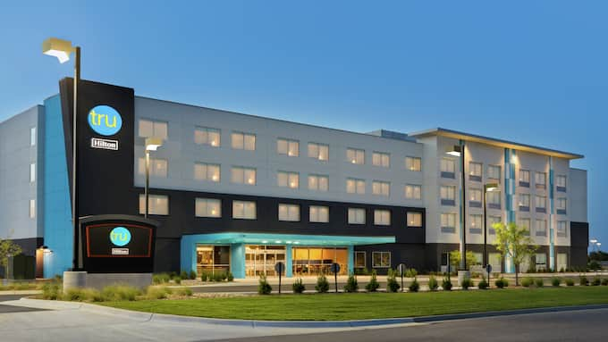
Tru by Hilton Wichita Northeast
1236 North Greenwich Rd. Wichita, Kansas 67206 USA
$98 - $108 USD/Night

https://www.hilton.com/en/book/reservation/rooms/?ctyhocn=MCIWIRU&arrivalDate=2024-04-09&departureDate=2024-04-12&groupCode=90H&room1NumAdults=1&cid=OM%2CWW%2CHILTONLINK%2CEN%2CDirectLink

Short Link: https://tinyurl.com/ATEATRU
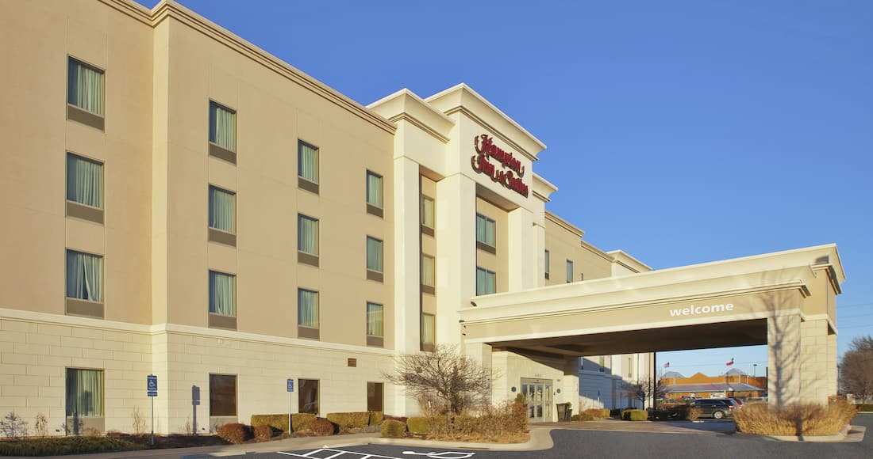
Hampton Inn & Suites Wichita-Northeast
2433 North Greenwich Road Wichita, Kansas 67226 USA
$119 USD/Night
https://www.hilton.com/en/book/reservation/rooms/?ctyhocn=ICTNOHX&arrivalDate=2024-04-09&departureDate=2024-04-12&groupCode=CHHWST&room1NumAdults=1&cid=OM%2CWW%2CHILTONLINK%2CEN%2CDirectLink

Short Link: https://tinyurl.com/ATEAHAMPTON

